Start Type1 App

Open MasterType1Sheet.xlsx

C:\Users\VMAK CAPITAL\AppData\Roaming\MetaQuotes\Terminal\CEA95A93FC8D185DD2235895C53A5FFF\MQL4\Files

Entering B or S we use 60mins

B: 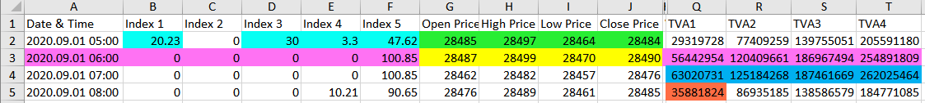

1. Current Index 4 or 5 must be 100+.
2. Past Index Values Must have 4 values in Index 1,2,3,4,5. 0 don’t count.
3. Current OPEN, HIGH, LOW, CLOSE > Past OPEN, HIGH, LOW, CLOSE

Do Nothing:

1. Check per TVA. If Current is > than Past do nothing. Per 15mins

C:

1. Check per TVA. Must be < than Past. Per 15mins

S: 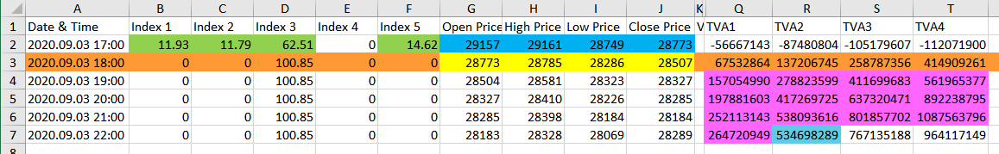

1. Current Index 2 or 3 must be 100+.
2. Past Index Values Must have 4 values in Index 1,2,3,4,5. 0 don’t count.
3. Current OPEN, HIGH, LOW, CLOSE < Past OPEN, HIGH, LOW, CLOSE

Do Nothing:

1. Check per TVA. If Current is < than Past do nothing. Per 15 mins

C:

1. Check per TVA. Must be > than Past. Per 15mins.